**Computer Science Club**

***General Meeting***

***2-2-2012***

***Agenda***

* A Word From Career Services ***Dan Gomez***

**Looking to the future…**

* Trip to Midway
* Resume building/internships
* Valentine’s Day
* Debugger tutorial
* Test-driven coding/Git Hub
* Exam help
  + What Career Services offers
  + What exactly goes on in the CS Club?
* General club information ***David, Curtis***

**Include your group’s mission statement, purpose, goals or all of the above.**

* + T-shirts
  + Events committees
    - Bilbo
    - V-day events
    - Debugger tutorial
    - Club sign up
* Computer Science Outlook ***Sam, Dr. Liow***
  + 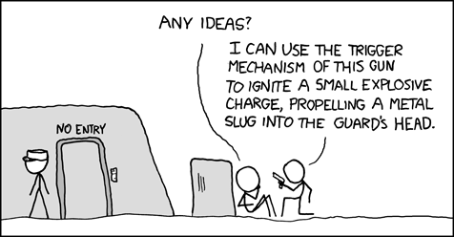Game presentations
  + Best 100 Jobs
  + CS career facts
* Plan ahead ***Tomas***
  + Course Schedule
  + Lunch Meeting
* Portfolio

***Mark your calendar***

* General meetings

**Mission statement:** Columbia College Computer Science Club exists primarily to further the cause of the Computer Science Department of Columbia College. It shall be dedicated to providing Columbia College students with opportunities whereby they can advance their knowledge of the different branches of Computer and Information Sciences and get a hands-on experience with its various applications.

* + March – 3/1
  + April – 4/5
  + May – 5/3

**Include your group’s mission statement, purpose, goals or all of the above.**